26th August 2013

**YOKOHAMA to Exhibit at Russia’s InterAuto 2013**

Tokyo - The Yokohama Rubber Co., Ltd., announced today that it will participate in InterAuto

2013, Russia’s 9th international exhibition of automotive industry, to be held in Moscow during 28th to 31st August. The YOKOHAMA exhibit will feature three core tyre brands - the high-performance “ADVAN” line, the environmentally friendly “BluEarth” line, and the winter-safe “iceGUARD” line—while also displaying tyres for trucks and buses, and aluminium wheels. The exhibit is designed to further raise awareness in Russia of YOKOHAMA as a comprehensive tyre manufacturer and spread the “High-Performance YOKOHAMA” brand image.

The “ADVAN” zone at the show will introduce to Russian car enthusiasts the diverse “ADVAN” line, including the “ADVAN A005” racing tyre, the YOKOHAMA’s global flagship tyre “ADVAN Sport V105”, which is being factory-fitted on many premium automobiles, and the “ADVAN S.T.”, the next-generation of SUV tyre. To further appeal to the high-performance of “ADVAN” tyres, the exhibit will display some of the racing vehicles and tuned cars that are participating in the Russian motor sports scene with support from YOKOHAMA and our high brand recognition.

The “BluEarth” zone will feature the entire line of “BluEarth” tyres available in Russia, including the “BluEarth AE-01”, a fuel-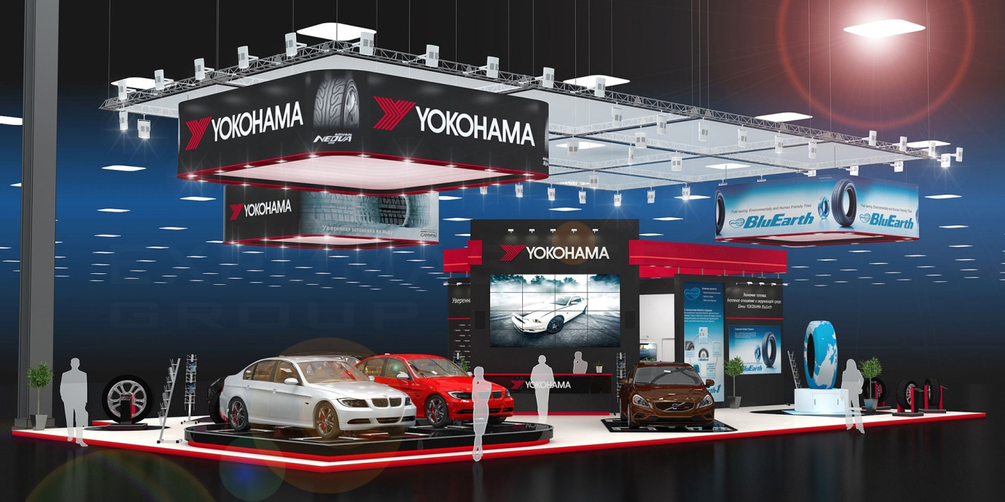efficient tyre for passenger cars that debuted in Russia earlier this year, and the “GEOLANDAR SUV” tyre employing “BluEarth” technology. The “iceGUARD” zone will display the brand’s core “iceGUARD STUD iG35” and the “iceGUARD STUDLESS iG50” for passenger cars. The display will appeal to the “BluEarth” line’s contribution to environmental protection through higher fuel efficiency and the “iceGUARD” lines’ high performance on ice and snow, which contributes to safer winter driving. The exhibit will also introduce our truck and bus tyres, in particular the “ZEN” line, which emphasizes environmental performance.

Russia is one of the world’s largest tyre markets, and YOKOHAMA boasts the major local market share among foreign tyre manufacturers. The Company’s local passenger car tyre plant began operations in December 2011 and started operating at full capacity (1.4 million tyres a year) this summer. YOKOHAMA is strengthening both its product-supply capabilities and marketing power in Russia in line with the continued expansion of its local sales network.